Name__________________________ Dare____________________ Period______
History Of Motion Pictures https://www.britannica.com/art/history-of-the-motion-picture
Read and answer as best you can-
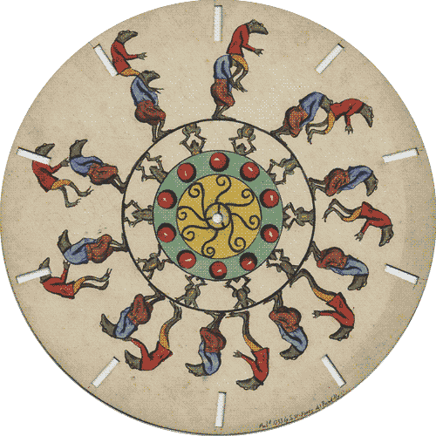
1. Early Years, 1830–1910
What is as persistence of vision and the phi phenomenon?

2. What is the phenakistoscope, c. 1832 (or go google it)

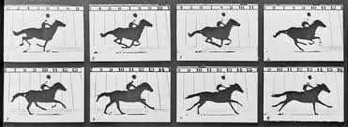
3. Who was British American photographer Eadweard Muybridge and what did he do?

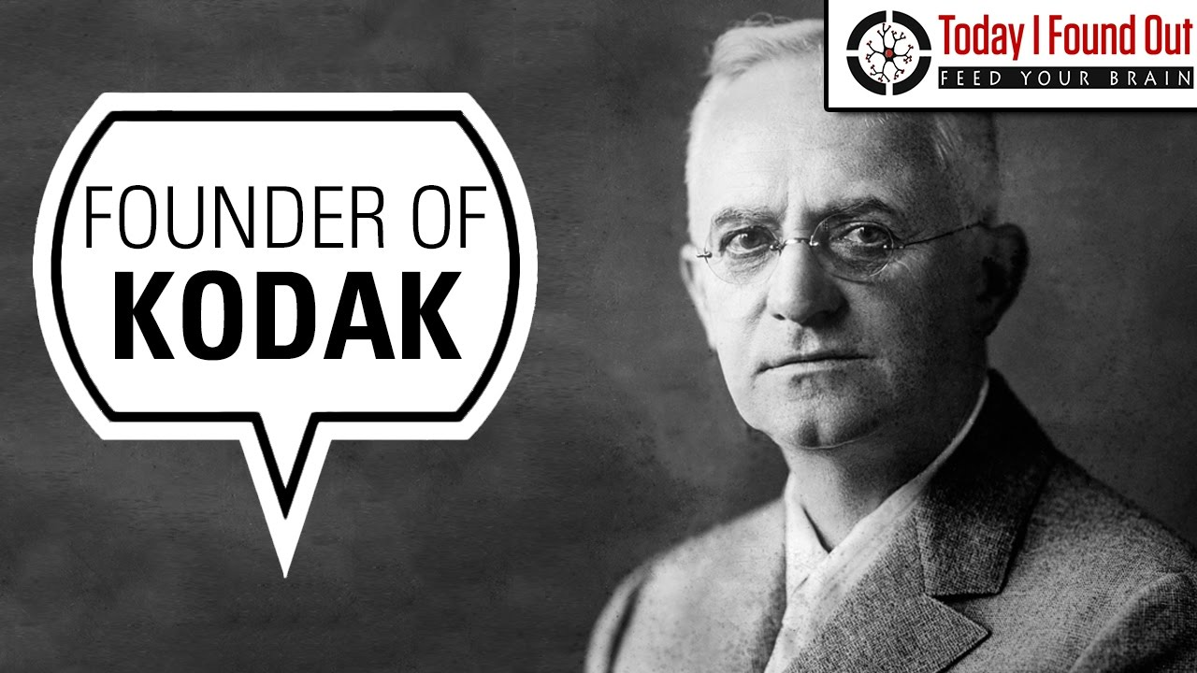
4. Who was the inventor and industrialist George Eastman, and what event was crucial to the development of cinematography?
Edison and the Lumière brothers
5. Who was Thomas Alva Edison? What did he create?

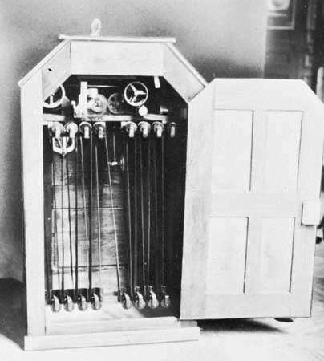

What did he commission Dickson, a young laboratory assistant, to do?

What was the Kinetoscope?

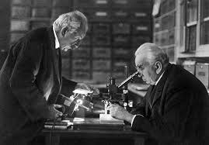
6. Who were the Lumière brothers, Auguste and Louis?

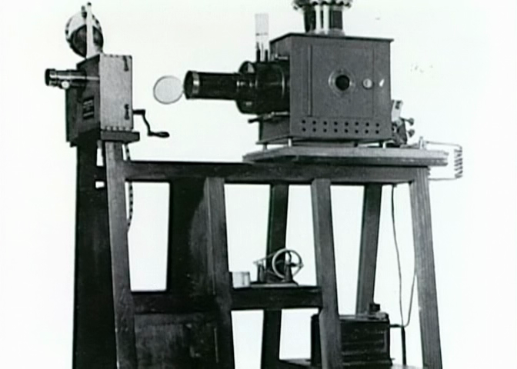

What was the cinématographe?

Méliès and Porter
7. Who was Georges Méliès.? What type of filming did he do?

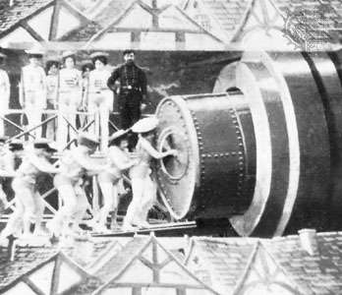

What was Voyage dans la lune (A Trip to the Moon)?
Click and watch on class website

Why did Georges Méliès lose his audience in the late 1910s?

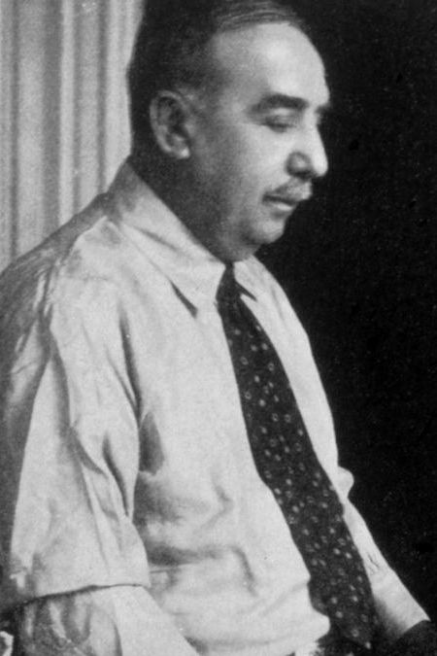

8. Who was Edwin S. Porter?

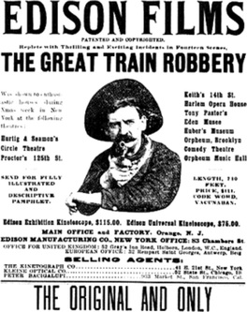

What is important in film history about Porter’s
The Great Train Robbery (1903)?

