Photoshop CIB 6 Chapter 7 Typographic Design
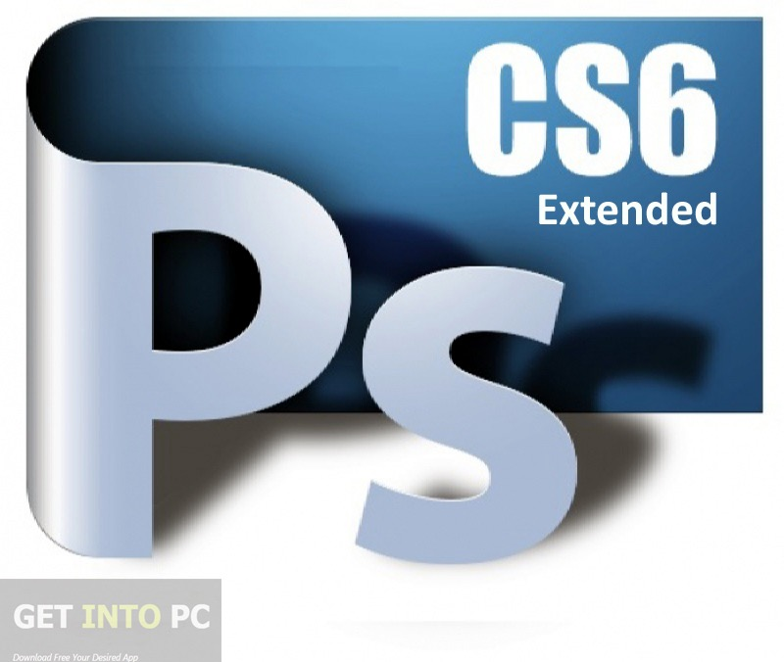
Name_____________Period_______ Date____
Use this sheet and the original Photoshop CIB .pdf to answer all questions and submit via our class website
Review questions
. 1 How does Photoshop treat type?

. 2 How is a text layer the same as or different from other layers in Photoshop?

. 3 What is a clipping mask, and how do you make one from type?

. 4 What is a paragraph style?

About type
Type in Photoshop consists of mathematically defined shapes that describe the let- ters, numbers, and symbols of a typeface. Many typefaces are available in more than one format, the most common formats being Type 1 or PostScript fonts, TrueType, and OpenType (see “OpenType in Photoshop” later in this lesson).
When you add type to an image in Photoshop, the characters are composed of pixels and have the same resolution as the image file—zooming in on characters shows jagged edges. However, Photoshop preserves the vector-based type outlines and uses them when you scale or resize type, save a PDF or EPS file, or print the image to a PostScript printer. As a result, you can produce type with crisp, reso- lution-independent edges, apply effects and styles to type, and transform its shape and size.
Creating a clipping mask from type
A clipping mask is an object or a group of objects whose shape masks other artwork so that only areas that lie within the clipping mask are visible. In effect, you are clipping the artwork to conform to the shape of the object (or mask). In Photoshop, you can create a clipping mask from shapes or letters. In this exercise, you’ll use letters as a clipping mask to allow an image in another layer to show through the letters.
Tool tips from the Photoshop evangelist
type tool tricks
• Shift-click in the image window with the Type tool (T) to create a new type layer—in case you’re close to another block of type and Photoshop tries to autoselect it.
• Double-click the thumbnail icon on any type layer in the Layers panel to select all of the type on that layer.
• With any text selected, right-click (Windows) or Control-click (Mac OS) on the text to access the context menu. Choose Check Spelling to run a spell check.
Creating paragraph styles
You’ll create a paragraph style to format the rest of the text. A paragraph style is a collection of type attributes that you can apply to an entire paragraph with a single click. Paragraph styles in Photoshop are similar to styles in page layout applications such as Adobe InDesign and popular word-processing applications, but you’ll prob- ably notice some differences in the way they work. By default, all text you create in Photoshop has the Basic paragraph style applied.

