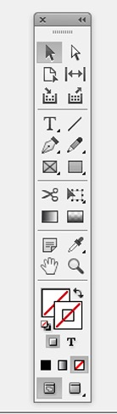
INDESIGN CS 6 TOOLBAR -Fill out and Learn all Tools
Name______________________ Period _______________ Date____________
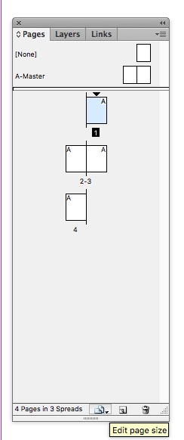
Pages Palette
Fill in the blanks please

Find 3 Weblinks For Good Help Tutorials for InDesign CS 6

Link 1______URL Address___________________________________________________
Title Of Website____________________________________________________________
What do you see on this website?

Link 2______URL Address___________________________________________________
Title Of Website____________________________________________________________
What do you see on this website?

Link 3______URL Address___________________________________________________
Title Of Website____________________________________________________________ What do you see on this website?

